Online food ordering
Overview:
Online food ordering services are websites that feature interactive menus allowing customers to place orders with local restaurants.

A customer will search for a favorite restaurant, choose from available items, and choose delivery or pick-up. Payment can be by credit card or cash, with the restaurant returning a percentage to the online food company.

Many of the times you must have seen pamphlets/brochures displaying the food items of restaurants, lying here and there on roads and finally sent to dump. Local restaurants and eating joints use to distribute their pamphlets, flyers and brochures to advertise the newly opened or already running service outlet, in their surrounding area. This practice of advertising merely adds to the restaurant cost with little profits. Now-a-days, the mighty Internet technology is being incorporated in restaurant ordering service in the form of Online Food Ordering System.
The online food ordering system is a kind of software which can be easily integrated with the restaurant website. The software is so simple to use that the user doesn’t need to be a techno smart. With an easy access to Internet, the online food ordering system makes it highly convenient for restaurateurs to take food orders from their customers. Phone /brochure based ordering are being left far behind by online restaurant ordering systems.

Not only restaurateurs, but customers too are benefited from this software. They are freed from frustrating situation of missed orders, longer phone hold on, worry of disclosing personal information on phone etc. They get fully satisfied with the accurate and faster services provided by the restaurants using online food ordering software. Along with amazing features and advantages, online food ordering systems offer a prompt and courteous customer care, apparent economics and incessant improvements. Customer convenience and care are the main concerns for every business and Online Food Ordering Systems are really meant for that.

Benefits include no telephone miscommunication, easy specification of special requests and paperless menus for local restaurants right at your finger tips. Waiter.com also helps you save and manage time. Save favorite orders for future use and you can reduce order time to as little as 15 seconds, or, if you don't have time to order during the work day, order ahead and specify a later preparation time... Ordering food for takeout can also rescue you from long lines during the lunch hour.

Mission:
To create a food-ordering website that enable users to search restaurants and order foods and give facilities to this process.
Plan:
The website will be divided into 3 main area based on user type:
1- Moderators : Have full authorization to access all the features through a custom control panel.
2- Restaurant Owners: Can add, modify, activate and deactivate his Restaurants profiles and manage meals and prices.
3- Food Buyers: Can search restaurants, add foods to shopping cart and make food orders.
Detailed Features:
The most important part of the site is the Food buyers, so most of the features would target food buyers.
1- After creating a “Food Buyer” account, food buyer can search restaurants and foods based on multiple criteria (Restaurant Name, City, Food Price, Food type ...). While browsing foods buyers can add any food to their shopping cart and make the order at the end. Food buyers will be given an easy to use user interface to ensure that anyone can use the system without any confusing. Buyer will be given many options to specify his address accurately, like an advanced map, to guarantee successful and fast delivery.
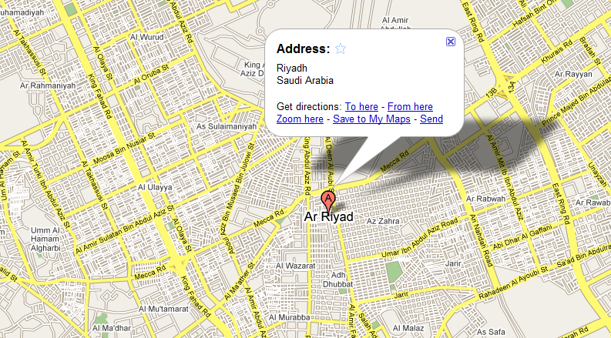
Food buyer can add restaurants to his favourite list, share restaurants with his friends and give his comments and rating about the services of any restaurant. They can also make a complaint about a restaurant services.
2- Restaurant Owners will have a “Restaurant Owner” account, from which he can manage his restaurants profiles and specify the food categories, meals, delivery duration and prices.
Each restaurant can have pictures, food menu, working time and delivery fees. Owners can set the status of his restaurant services (active, inactive) at any time. Restaurant owners will be notified about any food ordering to their restaurant by emails.
3- Moderators can manage all the previous accounts by adding, modifying or deleting. They can add food categories. They have full access to the site features. Moderators can add News and events that will be published to the Home page.
All moderators operation will be logged (saved) to ensure security.

Software Structure:
Online food ordering software separate into three main sections:
- Administration section.
- Restaurateurs section.
- Normal user section.
In the following part we will describe each section of above sections:
- Administration section.
Allow software owner or administrators to:
  - Manage the whole software (web site).
  - Manage Restaurateurs (add, modify, delete, activate, and deactivate).
  - Manage countries, cities, and places.
  - Manage News that will add by Restaurateurs (add, modify, delete, activate, and deactivate).

- Restaurateurs section.
Allow Restaurateur administrator to:
  - Manage Restaurateur profile.
  - Manage the places that can serve.
  - Manage News (add, modify, delete, activate, and deactivate).
  - Manage food categories (add, modify, delete, activate, and deactivate).
  - Manage meals and their prices (add, modify, delete, activate, and deactivate).

- Normal user section.
Allow Normal user to:
  - Register with web site.
  - Manage his profile.
  - Search about restaurants that serve his place.
  - Choose and add meals to shopping cart.
  - Checkout the shopping cart to complete the process.
  - Save favorite meals to fast order.
  - View shopping history.
  - View order status.
  - Manage Addresses (add, modify, delete, activate, and deactivate);

Common Services:
- Web site will be in two languages.
- some pages as (feedback, contact us, about us)
- Online chat with web site customer service.
- Graphical Search.
- Search by restaurant name.

TIME FOR PROGRAMING:
WILL BE TAKE 20 DAYS
TIME OF DESIGHN:
WLL BE TAKE 5 DAYS
TOTALLY:25 DAYS + 5 days for Overview=30 days
SALER : 7000 RS

ــــــــــــــــــــــــــــــــــــــــــــــــــــــــــــــــــــــــــــــــــــــــــــــــــــــــــــــــــــــــــــــــــــــــــــــــــــــــــــــــــــ
BY: ABEER YAHIA
ABEERWX@HOTMAIL.COM
00967711695170

