C . V
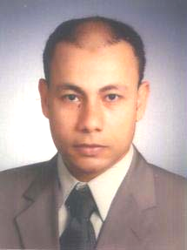
Name: Hassan Elsayed Hassan Elsayed Sharaf

Address: 3 Mahmoud Helal ST., Aldrasat, Mansura.

Tel: 010-9092902
050-9801375

Date and place of Birth: 29-10-1975 - Mansura

Marital State: Married and have one kid

Military Service: Exempted from the military service.

Scientific Qualifications:
Bachelor of Commerce –Accounting
Department- Mansura University – 2000
Special Qualifications:
* Fluency in both spoken /written English
* Excellent in all computer skills
Experiences:
* Working as accountant in medical
Pharmaceuticals company from 12-2000
to 7-2001.
* Working as accountant in computer company
from 11-2001 to 12-2002
* Working as accountant in group of company and
factory specialized in producing and marketing
plastic pipes and its fittings from 1-2003
to 31-7-2008.
* Working as accountant in group of 2 factories
and company ( Gravena ) from 1-2008 till now .

